**2016-2017 Contest Topic:**

**IS IT TIME TO PASS THE EQUAL RIGHTS AMENDMENT?**

The **Equal Rights Amendment** (**ERA**) was a [proposed amendment](https://en.wikipedia.org/wiki/Article_Five_of_the_United_States_Constitution#Proposing_amendments) to the  [United States Constitution](https://en.wikipedia.org/wiki/United_States_Constitution) designed to guarantee [equal rights for women](https://en.wikipedia.org/wiki/Gender_equality). In 1923, it was introduced in [Congress](https://en.wikipedia.org/wiki/United_States_Congress) for the first time.

Several attempts to ratify the amendment were made in 1972, 1978 and then a possible ratification in 1982, but it still has never been put into law.

Actress Patricia Arquette, who made headlines and brought new attention to the gender pay gap with her infamous [2015 Oscar speech](http://www.peoplestylewatch.com/people/stylewatch/package/article/0,,20881794_20903443,00.html) has started a petition to assure the passage of ERA NOW! "People think it's a women-only issue but it's not," Arquette told PEOPLE magazine. "It's an equality issue.

Filmmaker Kamala Lopez's new film, [Equal Means Equal](https://www.youtube.com/watch?v=bMIWOyk7YqM&feature=youtu.be), examines the startling effects of gender inequality in the United States, the inadequacy of current laws in place and the dedicated advocates who've been fighting for decades to rectify the situation.

**Is it time to pass the Equal Rights Amendment?  If so, how can this be accomplished?  How can organizations such as AAUW help in getting this amendment ratified once and for all?**





PO Box 160067

Sacramento CA 95816-0067

Website: www.aauw-ca.org

Email: speechtrek@aauw-ca.org

C A L I F O R N I A

**AAUW California**

*Speech Trek*

**1331 Garden Hwy, Suite 100**

**Sacramento, CA 95833**

**(916) 448-7795**

**email: speechtrek@aauw-ca.org**

**Local Branch Contact**

**Eleanor Stem Allen**

**Memorial Speech Contest**

**2016-2017**



The American Association of University Womenhas been empowering women as individuals and as a community since 1881. As a grass-roots organization, we have worked together to improve the lives of millions of women and their families through:

**AAUW** 

##### [RESEARCH](http://www.aauw.org/what-we-do/research/)

We analyze gender equity issues in education and the workplace.

[Campus Leadership](http://www.aauw.org/what-we-do/campus-programs/)

We help shape the lives of the next generation of women leaders.

[STEM Education](http://www.aauw.org/what-we-do/stem-education/)

We are leveling the playing field for girls and women in science, technology, engineering, and mathematics.

[Public Policy](http://www.aauw.org/what-we-do/public-policy/)

We advocate for policies that advance equity for women and girls.

[Legal Advocacy](http://www.aauw.org/what-we-do/legal-resources/)

We challenge sex discrimination in higher education and the workplace.

[Educational Funding](http://www.aauw.org/what-we-do/educational-funding-and-awards/)

We provide educational and lifelong learning opportunities for women.

AAUW CALIFORNIA was launched in San Francisco in 1888. We remain the state’s most active and diverse organization for women with nearly 10,000 members in more than 100 branches, plus 6,000 members-at-large.

Annually, AAUW CA sponsors Speech Trek**,** a speech contest for high school students. The students compete locally for prizes and the opportunity to become one of three finalists to present at the AAUW CAconvention for cash awards. See the AAUW CA website for videos of previous winners and contest details at [www.aauw-ca](http://www.aauw-ca).org (Mission Based Programs> Speech Trek) or email: [speechtrek@aauw-ca.org](mailto:speechtrek@aauw-ca.org)

##### HERE ARE THE BASICS

* Students prepare and present a five-six minute speech to their local AAUW CA branch on a theme revised each year, announced in this brochure and available on the AAUW CA website.
* Videos of the local branch winner’s speech will be used to select 3 finalists to compete at the AAUW CA convention. An additional two contestants will be named as 4th and 5th place winners. …………..………………………
* The final competition will be held at a State event for AAUW CA in April at a place to be determined. Expenses are paid for a trip to the convention for three student finalists and a parent or chaperone.

##### STATE LEVEL WINNERS WILL RECEIVE

First Prize - $1500

Second Prize - $1000

Third Prize - $ 500

Fourth Prize - $ 250

Fifth Prize - $ 150

**Invitation**

**Speech Trek**

If you believe that public speaking skills can be learned, as we do,and that, once attained, these skills:

**Invitation**

ADVANCE DEMOCRACY

by encouraging public discourse on societal issues, and

ADVANCE CAREERS

by enhancing interview and job-performance skills, then

##### WE INVITE YOU

to download contest instructions at: www.aauw-ca.org(Forms and Documents, > Speech Trek)

A speech contest will bring energy and recognition to you, your students and your local branch, enriching the lives of all who participate. Join us!

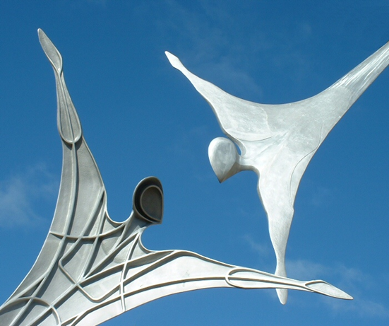

AAUW CA Empowers You

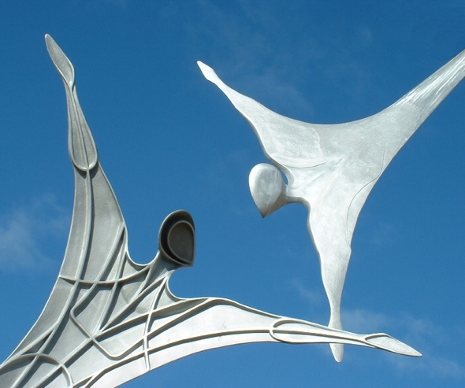

AAUW CA Empowering You



AAUW CA Empowering You



AAUW CA Empowering You